1. Results/discussion

The graph (Figure1) below shows the representation of the regression of loss function, the learning curve for each model. As, if is getter nearer to the 0th value it therefore represents it is getting better and did so after running a. number of executions later.

The model, if I were to do it differently may have come with various changes. One of the main things I would have carried out was co-variance analysis. I would have done this be seeing if some columns can actually be dropped from the dataset- this would have been implemented by using co-variant variables, in order to drop the columns to have less columns to compare. Furthermore, in terms of things I could or would have done different, I could have used a form of a general adversarial neural network in order to improve the fine-tuning process to a higher degree. In regards to the goals, I believe this was achieved as higher predictability was promoted. If carried out again I would have also wanted 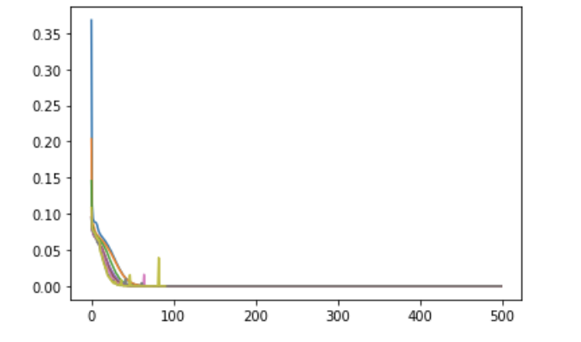to experiment with other types of neural networks such as modular neural networks for example. In addition to this I could have used more adequate pre-processing as then it would have meant that a featured analysis could have been implemented in order to determine which features are higher correlated to one another therefore increasing accuracy higher than the one that was outputted at 0.52 for example, in addition to this these results outputted were very inconsistent and unstable for the classifier ranging from anywhere from 50% to 80%. I could have used various steps in regards to pre-processing that may have solved this for example think I would have experimented with whitening.

Figure 1: Representation of learning curve for each of the models.